Toronto North Collegiate Model- 9in

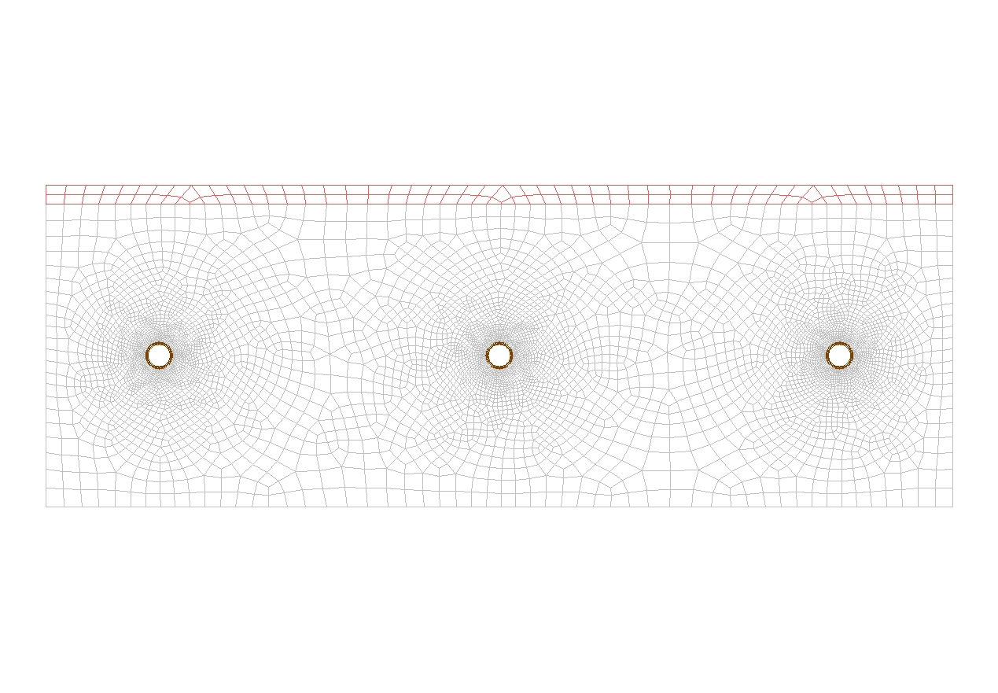

Material Properties
Material | Color | K-Value (BTUh/in °F)
Concrete | Gray | 0.045
Tile (1/2”) | Red | 0.0139
RAUPEX (5/8”) | Brown | 0.02

Go to next page for results and heat distribution.
Heat Distribution

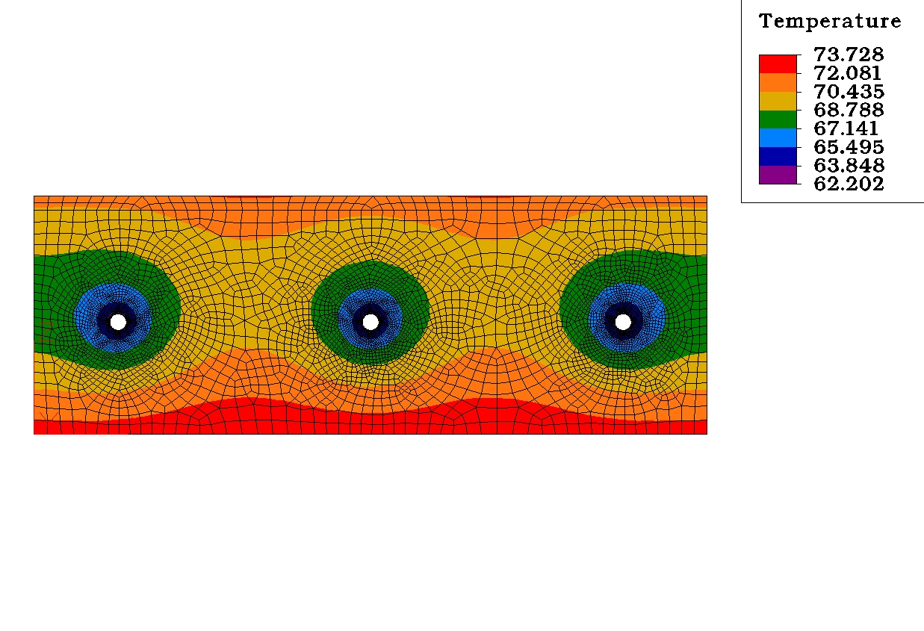

Additional Conditions:
5/8” RAUPEX 9 in OC
HEATING-Top / Bottom Air Temp : 72°F
COOLING- Top = 75°F , Bottom = 79°F
Film Coefficient: 1.65 (BTUh/ ft^{2 o}F), Still Air on the top and bottom of the model
There are no additional conditions applied to the model

With these conditions and the material properties listed the following results were obtained

MWT (°F) | Output Floor (BTU / ft²) | Output Ceiling (BTU / ft²) | Surface Temp Floor (°F) | Surface Temp Ceiling (°F) | Pipe Location
62 | 6.5 | 7.5 | 70-71 | 74-75 | 1.5” From Floor
62 | 5 | 9.4 | 71-73 | 72-74 | Middle
62 | 3.8 | 12.2 | 72-73 | 70-73 | 1.5” From Ceiling
105 | 18 | 13 | 80-85 | 79-80 | 1.5” From Floor
105 | 14.3 | 17.3 | 80-81 | 81-83 | Middle
105 | 11 | 22.5 | 78-79 | 82-88 | 1.5” From Ceiling

